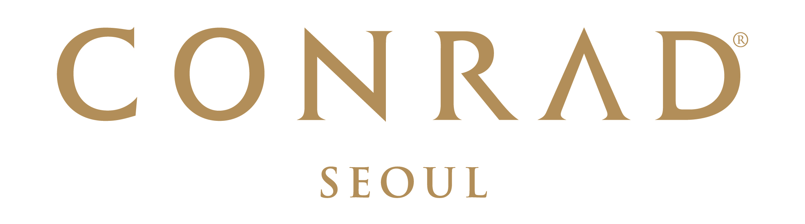  Conrad Seoul Reservation Form  The 25th Congress of the KSSMN & 2018 International Symposium  March 15th ~ 17th, 2018 | Conference Reservation  Conrad Seoul  10 Gukjegeumyung-ro (Yeouido),  Yeongdeungpo-gu, Seoul 07326, Korea  Phone:82-2-6137-7777  Email: Danbee.lee@conradhotels.com  Hyojeong.lee@conradhotels.com

RESERVATION DETAILS
Check-in Date: |  |  |  |  |  |  | Arrival Flight: |  |  |  |  |  |  |  | ETA:
Check-out Date: |  |  |  |  |  |  | Departure Flight: |  |  |  |  |  |  |  | ETD:
Last Name: |  |  |  |  |  |  | First Name:
Company: |  |  |  |  |  |  | Title:
Booking Contact: |  |  |  |  |  |  | Phone:
Fax: |  |  |  |  |  |  | Email:
Country: City:
Room Type |  |  |  |  |  | Rate |  |  |  |  |  | Number of Rooms |  |  |  | Number of Adults/Children
 | Deluxe Room with Standard Internet for 1Pax (Single) |  |  |  |  | KRW 210,000 / (Single) |  |  |  |  |  |  |  |  |  |  |  |  | /
 | Executive Room with Standard Internet for 1Pax (Single_ Executive Lounge Access) |  |  |  |  | KRW 290,000 / (Single) |  |  |  |  |  |  |  |  |  |  |  |  | /
 | Corner Suite Room with Standard Internet for 1Pax (Single) |  |  |  |  | KRW 360,000 / (Single) |  |  |  |  |  |  |  |  |  |  |  |  | /
*This special group rate for The 25th Congress of the KSSMN & 2018 International Symposium is only available upon hotel’s availability.
Preference: |  | Smoking |  |  | Non-smoking |  |  |  | Twin King
Remarks:
- All rates are subject to 10% VAT. No service charge will be applied.
- Quoted bedroom rates will be offered, based on Hotel’s availability and above rate will be offered for the participant of The 25th Congress of the KSSMN & 2018 International Symposium from 15th to 17th of March 2018.
- Executive Lounge Benefits: Express check in & out, breakfast at EFL Lounge, Coffee & Tea Service, Evening cocktail & canapés.
TRANSPORTATION
Limousine Transfer Required: |  |  | -Airport pick up & sending service to Conrad Seoul & Incheon International Airport : KRW 145,000 per car (subject to 10% tax)  -Any cancellations or amendments must be received at least 24 hours prior to the expected arrival date |  |  |  |  |  |  |  |  |  | Arrival |  |  |  | Departure
* We suggest KAL Limo Bus that runs every 20 mins. between Incheon International Airport and Conrad Seoul #6030. The rate is KRW 15,000/trip.
RESERVATION GUARANTEE
A credit card guarantee is required at the point of reservation. Please note that any cancellations or amendments must be received at least 14 days prior to the expected arrival date. Full payment for entire period of stay will be charged to the individual account 14 days prior to the expected arrival date. Any late cancellations or no shows will be charged the entire period of stay.
Guaranteed by: |  |  |  | Credit Card:
Cardholder’s Name: |  |  |  |  |  |  |  |  |  | Signature:
Credit Card Number: |  |  |  |  |  |  |  |  |  | Expiry Date:

CANCELLATION POLICY
No penalty for cancellations or shorten for 14 days early notice from arrival date.
Any late cancellations or no shows will be charged the entire period of stay.

TERMS AND CONDITIONS
- To enjoy the room block of The 25th Congress of the KSSMN & 2018 International Symposium, guest rooms will be provided with special rate upon hotel availability.
- Reservation received thereafter will be confirmed subject to availability at prevailing rates.
- Check-in time is after 16:00pm. Check-out time is before 11:00am. For any guests who would like immediate guaranteed access to their rooms prior to 16:00 PM check-in time, the room should be reserved from the previous evening. This will incur an additional one-night accommodation charge.
- This form must reach the hotel no later than 2nd March, 2018.
- By providing above mentioned credit card details, cardholder agrees to the reservation guarantee policy.
- Hilton HHonors members are entitled to earn both hotel points and airline miles. To enroll, please visit www.hiltonhonors.com.

